High level Design

Last update：2020-5-15

version：V1.0

author：Dean Peng

**1、Position Change(Buy/Sell)**

**1.1 positions page**

display Equity position, this page have Refresh/Buy/Sell three button

**1.2 flow chart**

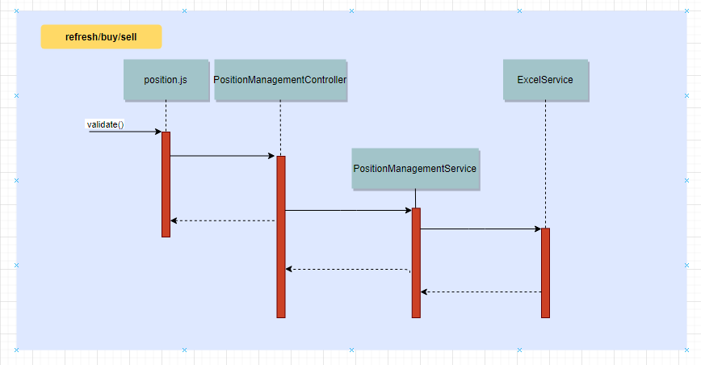

**2、Trade Change (update/cancel)**

**2.1 transaction page**

Display transaction details, this page have Refresh/Modify two buttons

**2.2 flow chart**

